**EtherNet/IP Level 2.06 Calendar Conditions**

This test concentrates on sending several settings to the printer and then reading all settings back to see what changed. For the general case of trying to upload a message, it would be nice if all values read reflected an initialized calendar block. Otherwise, it would be necessary to decode all the text to decide what needed to be retrieved.

There are many parts to this test. The plan was to build a single item using a single calendar block.

**"{{MMM}/{DD}/{YY} {hh}:{mm}:{ss} {TTT} {WW} {777} {EE} {FF}}"**

However, the printer would not accept this as text in a single item using a single calendar block. I broke it into three calendar blocks.

**"{{MMM}/{DD}/{YY} {hh}:{mm}:{ss}} {{TTT} {WW} {777}} {{EE} {FF}}"**

The printer again would not accept the message. The “EE” (Shift code) and “FF” (Time Count) caused the message to be rejected. The only indication was the message contained no text. Splitting the message into two items also failed. There are now two tests instead of one.

**"{{MMM}/{DD}/{YY} {hh}:{mm}:{ss}} {{TTT} {WW} {777}}"**

**" {{EE} {FF}}"**

**Test 1.**

Starting with test 1, building the message involved:

|  |  |  |  |  |  |  |
| --- | --- | --- | --- | --- | --- | --- |
| **Status/Path** | **Access** | **Class** | **Attribute** | **#Out** | **Data Out** | **Raw Out** |
| **Load Month and Day Substitutions Data** | | | | | | |
| 32 6C 01 66 | Set | Substitution_rules | Start_Year | 2 | 2010 | 07 DA |
| 32 6C 01 68 | Set | Substitution_rules | Month | 5 | 1,JAN | 01 4A 41 4E 00 |
| 32 6C 01 68 | Set | Substitution_rules | Month | 5 | 2,FEB | 02 46 45 42 00 |
| 32 6C 01 68 | Set | Substitution_rules | Month | 5 | 3,MAR | 03 4D 41 52 00 |
| 32 6C 01 68 | Set | Substitution_rules | Month | 5 | 4,APR | 04 41 50 52 00 |
| 32 6C 01 68 | Set | Substitution_rules | Month | 5 | 5,MAY | 05 4D 41 59 00 |
| 32 6C 01 68 | Set | Substitution_rules | Month | 5 | 6,JUN | 06 4A 55 4E 00 |
| 32 6C 01 68 | Set | Substitution_rules | Month | 5 | 7,JUL | 07 4A 55 4C 00 |
| 32 6C 01 68 | Set | Substitution_rules | Month | 5 | 8,AUG | 08 41 55 47 00 |
| 32 6C 01 68 | Set | Substitution_rules | Month | 5 | 9,SEP | 09 53 45 50 00 |
| 32 6C 01 68 | Set | Substitution_rules | Month | 5 | 10,OCT | 0A 4F 43 54 00 |
| 32 6C 01 68 | Set | Substitution_rules | Month | 5 | 11,NOV | 0B 4E 4F 56 00 |
| 32 6C 01 68 | Set | Substitution_rules | Month | 5 | 12,DEC | 0C 44 45 43 00 |
| 32 6C 01 6D | Set | Substitution_rules | Day_Of_Week | 5 | 1,MON | 01 4D 4F 4E 00 |
| 32 6C 01 6D | Set | Substitution_rules | Day_Of_Week | 5 | 2,TUE | 02 54 55 45 00 |
| 32 6C 01 6D | Set | Substitution_rules | Day_Of_Week | 5 | 3,WED | 03 57 45 44 00 |
| 32 6C 01 6D | Set | Substitution_rules | Day_Of_Week | 5 | 4,THU | 04 54 48 55 00 |
| 32 6C 01 6D | Set | Substitution_rules | Day_Of_Week | 5 | 5,FRI | 05 46 52 49 00 |
| 32 6C 01 6D | Set | Substitution_rules | Day_Of_Week | 5 | 6,SAT | 06 53 41 54 00 |
| 32 6C 01 6D | Set | Substitution_rules | Day_Of_Week | 5 | 7,SUN | 07 53 55 4E 00 |
| **Build the Message** | | | | | | |
| 32 7A 01 65 | Set | Index | Automatic_reflection | 1 | 1 | 01 |
| 32 7A 01 66 | Set | Index | Item | 2 | 1 | 00 01 |
| 32 67 01 74 | Set | Print_format | Dot_Matrix | 1 | 5x8(5x7) | 03 |
| 32 67 01 77 | Set | Print_format | Barcode_Type | 1 | None | 00 |
| 32 67 01 75 | Set | Print_format | InterCharacter_Space | 1 | 1 | 01 |
| 32 67 01 71 | Set | Print_format | Print_Character_String | 64 | {{MMM}/{DD}/{YY} {hh}:{mm}:{ss}} {{TTT} {WW} {777}} | 7B 7B 4D 4D 4D … |
| **Enable the Desired Substitutions** | | | | | | |
| 32 7A 01 6F | Set | Index | Calendar_Block | 1 | 1 | 01 |
| 32 69 01 75 | Set | Calendar | Substitute_Month | 1 | Enable | 01 |
| 32 69 01 7A | Set | Calendar | Substitute_Day_Of_Week | 1 | Enable | 01 |
| 32 7A 01 65 | Set | Index | Automatic_reflection | 1 | 0 | 00 |
| 32 7A 01 64 | Set | Index | Start_Stop_Management_Flag | 1 | 2 | 02 |

Browser screen == Item 1, Calendar block 1.: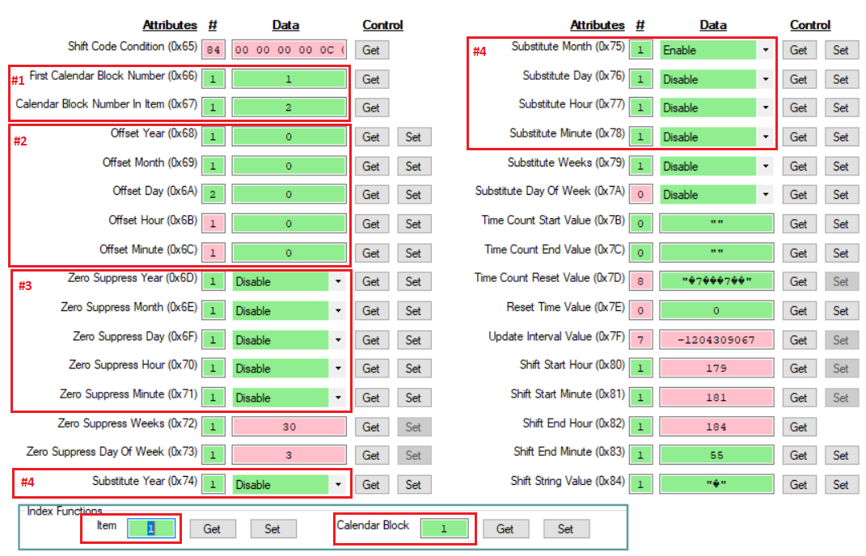

Observations (only areas outlined in red are pertinent to this test):

1. Item 1 hase two calendar blocks starting a calandar block 1.
2. Offset Hour and Offset Minute only returned 1 byte. I tried sending out a -20 (0xFF 0xEC) and the value returned was 0.
3. Worked.
4. Worked.

Browser screen == Item 1, Calendar block 2.:

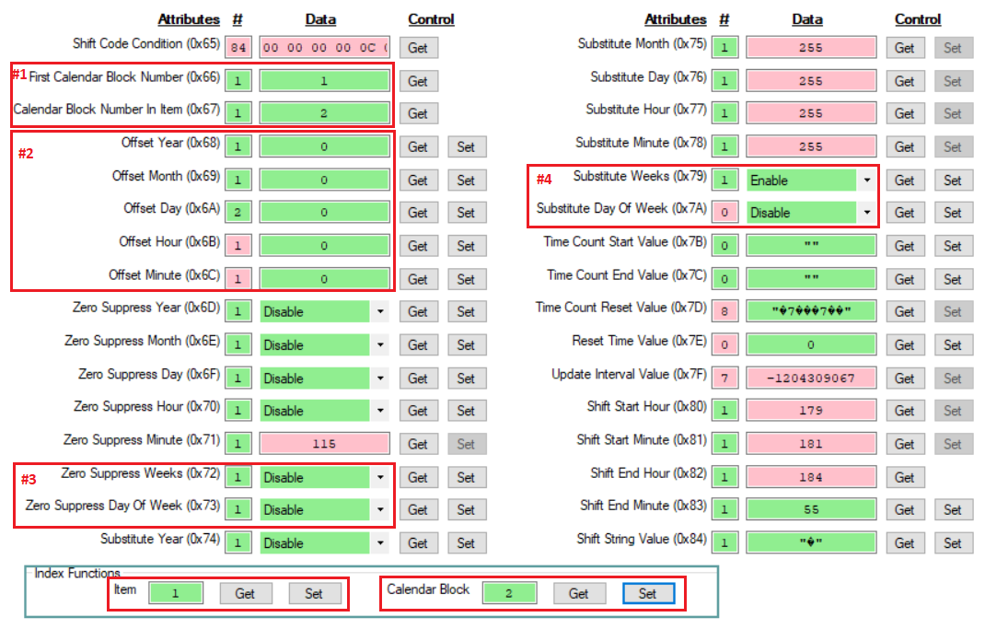

Observations (only areas outlined in red are pertinent to this test):

1. Item 1 hase two calendar blocks starting a calandar block 1.
2. Offset Hour and Offset Minute only returned 1 byte. . I tried sending out a -20 (0xFF 0xEC) and the value returned was 0.
3. Worked.
4. Substitute day of week returned 0 bytes.

Browser substitution screen.

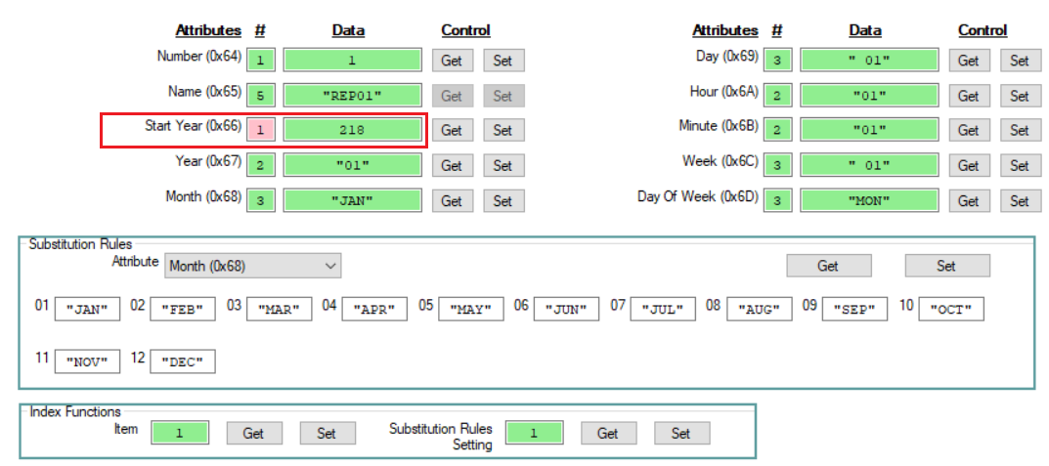

Issues:

* .The date start was sent as 2010 (0x07 0xDA). The date code returned as 1 byte (0xDA).

All other controls on the form worked.

**Test 2.**